GenomeFlow-2D Manual

# Visualize 2D Dataset

## GenomeFlow Home Screen

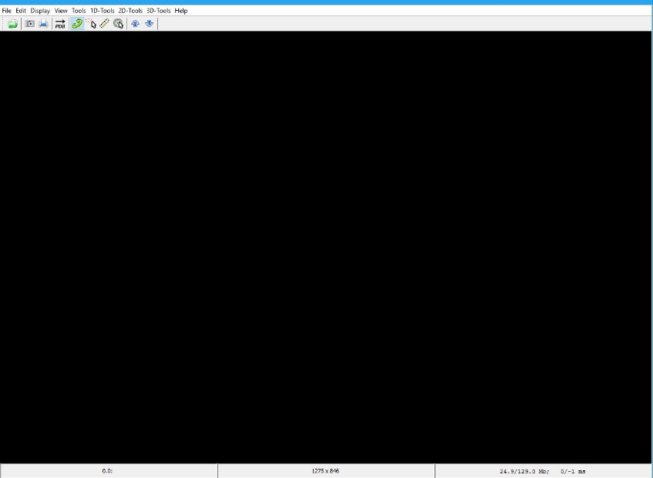

## Navigation to 2D Visualization window

To use the 2D functions, Navigate to the 2D-Tools menu in the Menu bar.

Select the Submenu, Visualize Dataset

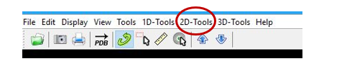

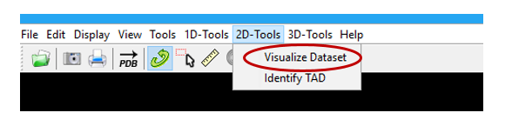

## Graphical User Interface window

The 2D Graphical User Interface (GUI) window below pops up once you click on the Visualize Dataset

Sub-menu.

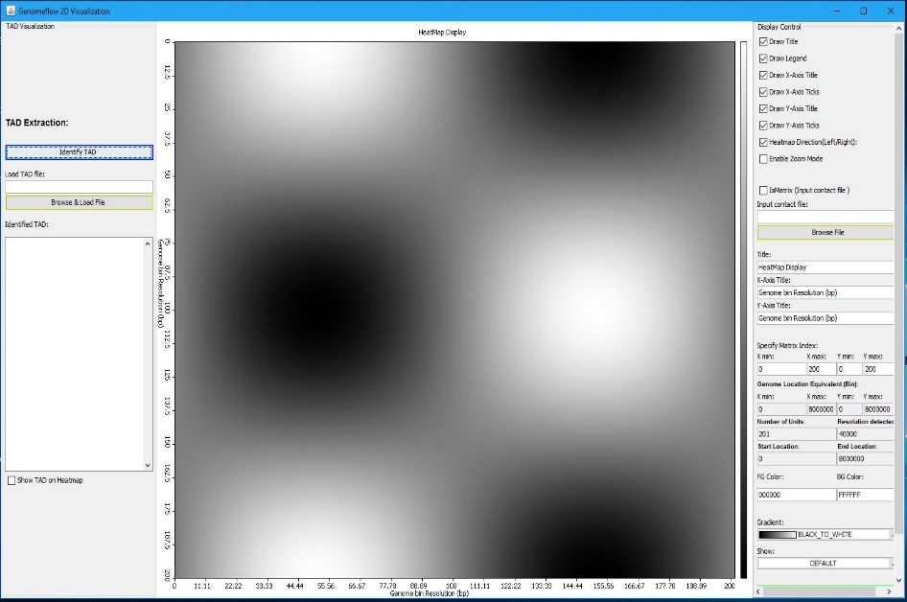

## Graphical User Interface (GUI) Segments

The 2D Graphical User Interface (GUI) window is divided into 3 segments: LEFT, CENTER, AND RIGHT.

* 1. The RIGHT: Contains the Display Controls for the data heatmap
  2. The CENTER: It displays the dataset in heatmap format
  3. The LEFT: Contains the TAD Visualization controls

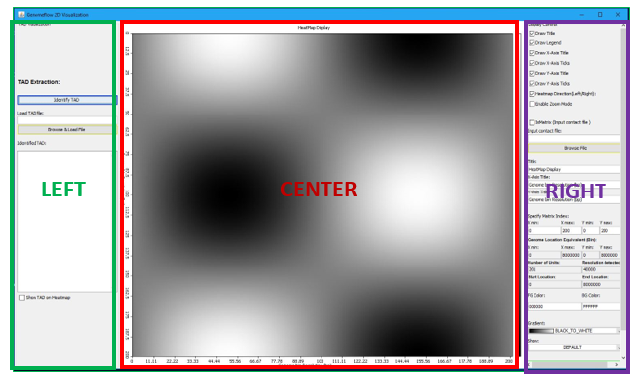

## The RIGHT Segment - Display Controls

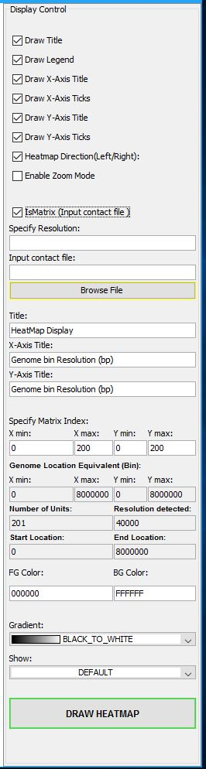

Show/Hide Legend

Show/Hide X-Axis Ticks

Show/Hide Y-Axis Ticks

Enter Data Resolution (if IsMatrix is checked)

Add the Title Label

Add the Y-Axis Title Label

Dataset Genome Location equivalent of X min, X max. Y min, and Y max

Resolution detected for input dataset

Background Color

Choose Color Gradient

Draw the input data as Heatmap

Enable Heatmap Zoom

Show/Hide Title

Show/Hide X-Axis Label

Show/Hide Y-Axis Label

Change heatmap direction

Indicate if dataset is a Matrix

Browse and select input data

Add the X-Axis Title Label

X min: Minimum X-axis index X max: Maximum X-axis index Y min: Minimum Y-axis index Y max: Maximum X-axis index

Number of Bins/Regions identified from dataset

Dataset Start Genome Location

Foreground Color

Calculate the Pearson, Spearman and Tanh of data and Visualize

Dataset End Genome Location

## The CENTER Segment – Display Area

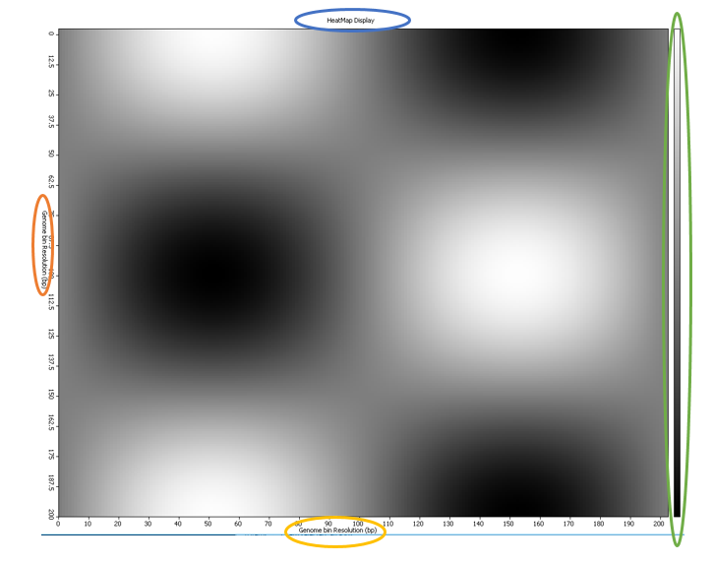

|  |  |
| --- | --- |
| Sphere Representation | Description |
|  | Heatmap Title |
|  | X-Axis Label |
|  | Y-Axis Label |
|  | Color Gradient. [Top means High, Bottom means Low] |

## The LEFT Segment – TAD Visualization

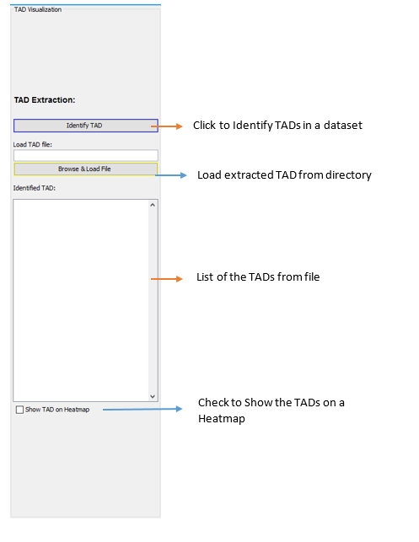

# TAD Identification

## Navigation to TAD Identification window

To use the 2D functions, Navigate to the 2D-Tools menu in the Menu bar.

Select the Submenu, Identify TAD



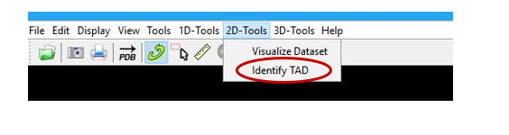

## Graphical User Interface window

The Graphical User Interface (GUI) window below pops up once you click on the Identify TAD

Sub-menu.

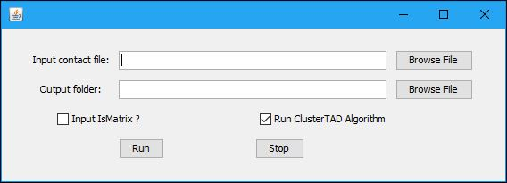

## TAD identification window controls

1. The function of each button is labelled below:

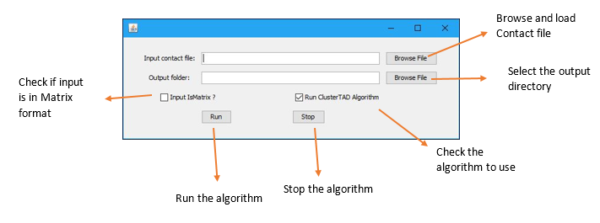

1. If the Input IsMatrix? Checkbox is checked, the Data Resolution is required from the user.

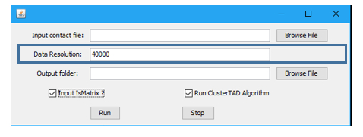

# Demonstration

## How to visualize a dataset in 2D Heatmap?

1. Goto Genome Home Screen

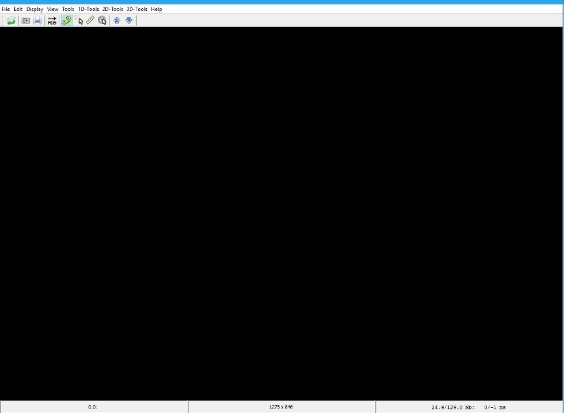

1. Click on the 2D-Tools Menu in the Home Screen



1. Click on the Visualize Dataset Sub-menu



1. Click on the Browse File button in the Display Control of the RIGHT Segment
2. Click the Draw Heatmap button to visualize the dataset on a Heatmap

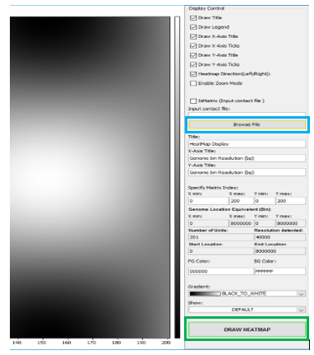

1. Following Steps 1 to 5 the Heatmap below is shown for the “sample_data.txt”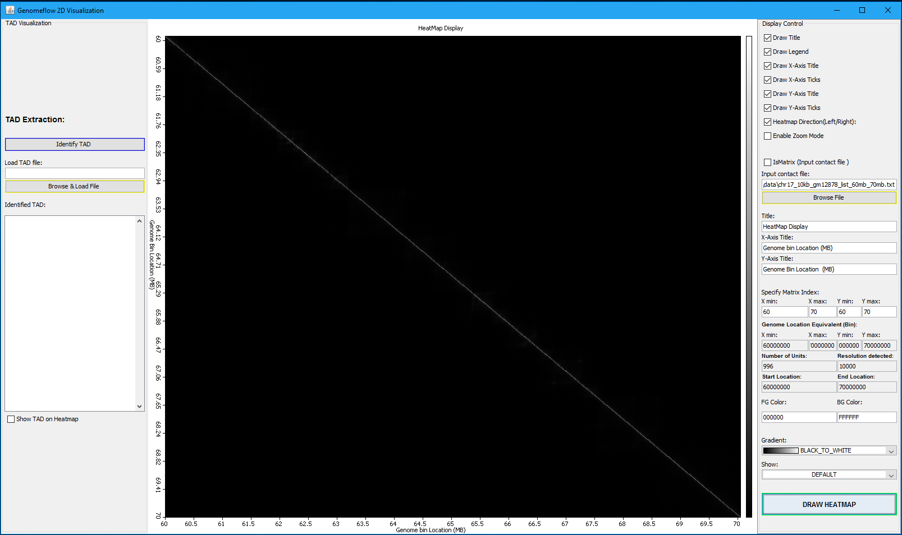
2. The default input data format is a Tuple. That is input data has 3 columns, column 1 and 2 represent the pair genomic location in contact, and column 3 represent the interaction frequency between them. An example is shown below:  
   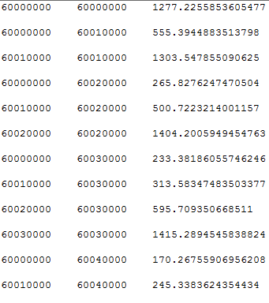

## Effect of Check boxes in the Display control

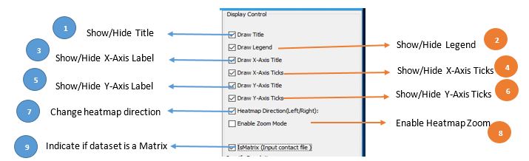

1. Click on the Draw Title check box to determine the Heatmap Title visibility. Check to Show, Uncheck to hide.
2. Click on the Draw Legend check box to determine the Heatmap Gradient visibility. Check to Show, Uncheck to hide.
3. Click on the Draw X-Axis Title check box to determine the Heatmap X-Axis Title visibility. Check to Show, Uncheck to hide.
4. Click on the Draw X-Axis Ticks check box to determine the Heatmap X-Axis Ticks visibility. Check to Show, Uncheck to hide
5. Click on the Draw Y-Axis Title check box to determine the Heatmap Y-Axis Title visibility. Check to Show, Uncheck to hide.
6. Click on the Draw Y-Axis Ticks check box to determine the Heatmap Y-Axis Ticks visibility. Check to Show, Uncheck to hide
7. Click on the Heatmap Direction (Left / Right) check box to determine the Heatmap draw direction. Check to draw from Left to Right, uncheck to draw from Right to Left.
8. Click on the Enable Zoom Mode check box to enable zoom in or out. Check to zoom, uncheck to return to default.
9. Click on the IsMatrix check box if input is in Matrix format. Check to specify input data is in Matrix form, uncheck to accept default input format.

## Effect of Text boxes in the Display control

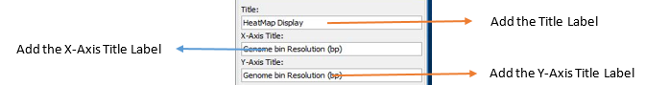

1. Enter the Heatmap, the X-Axis, and the Y-Axis title in the textbox as shown above.

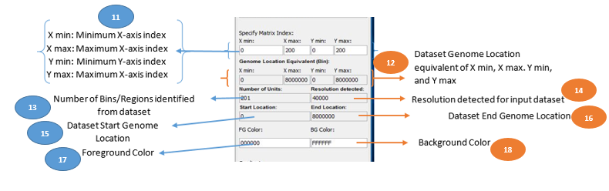

1. Shows the minimum and maximum index for X-Axis and Y-Axis for the input dataset. User can specify a new X-Axis and Y-Axis range, and the data will be shown on the Heatmap Display.
2. Shows the equivalent of the X and Y Axis label in 11 above in Genomic Location. This conversion is done based on the Resolution of the dataset.
3. It shows the number of bins/Regions in the dataset extractable based on the input dataset resolution.
4. It detects the resolution of the dataset from the dataset.
5. It shows the Genomic Start location of the input dataset.
6. It shows the End Start location of the input dataset.
7. Specify the foreground color for the heatmap display.
8. Specify the background color for the heatmap display.

## Effect of Dropdown list in the Display control

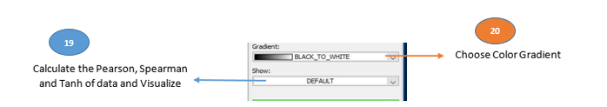

1. Show the Default, Pearson, Spearman, and Tanh equivalent of dataset. Heatmap below shows the representation of the dataset for each of them.

**Pearson**

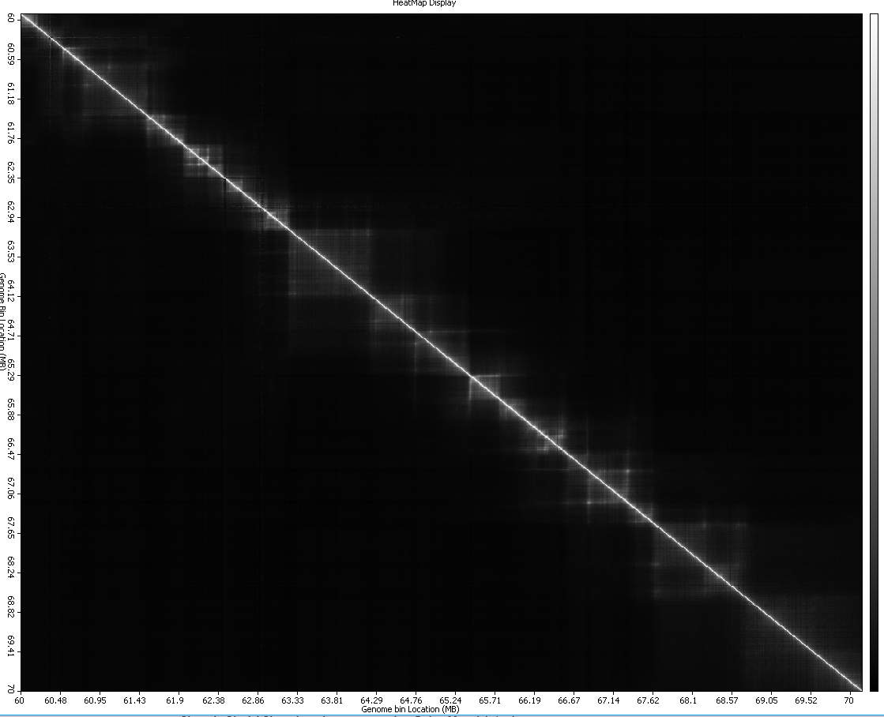

**Spearman**

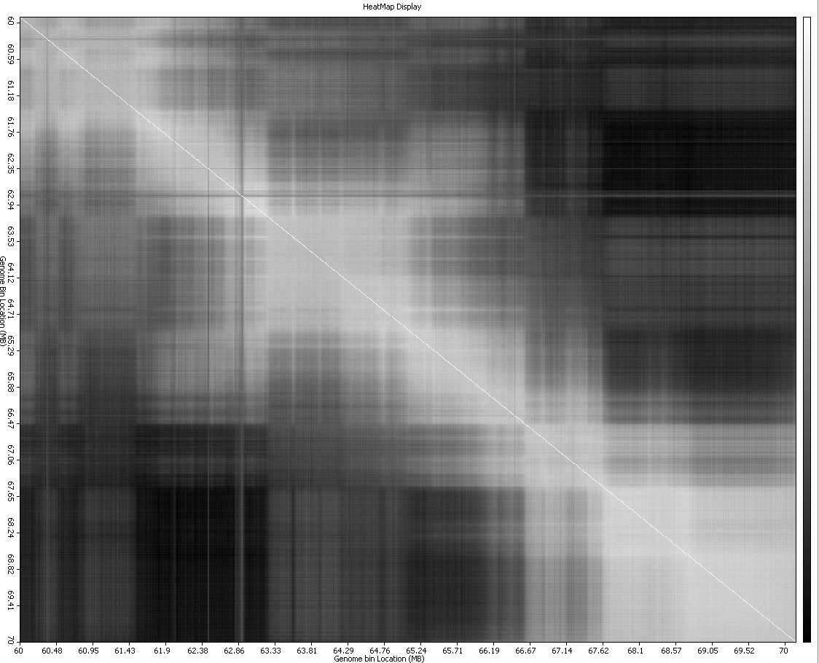

**Tanh**

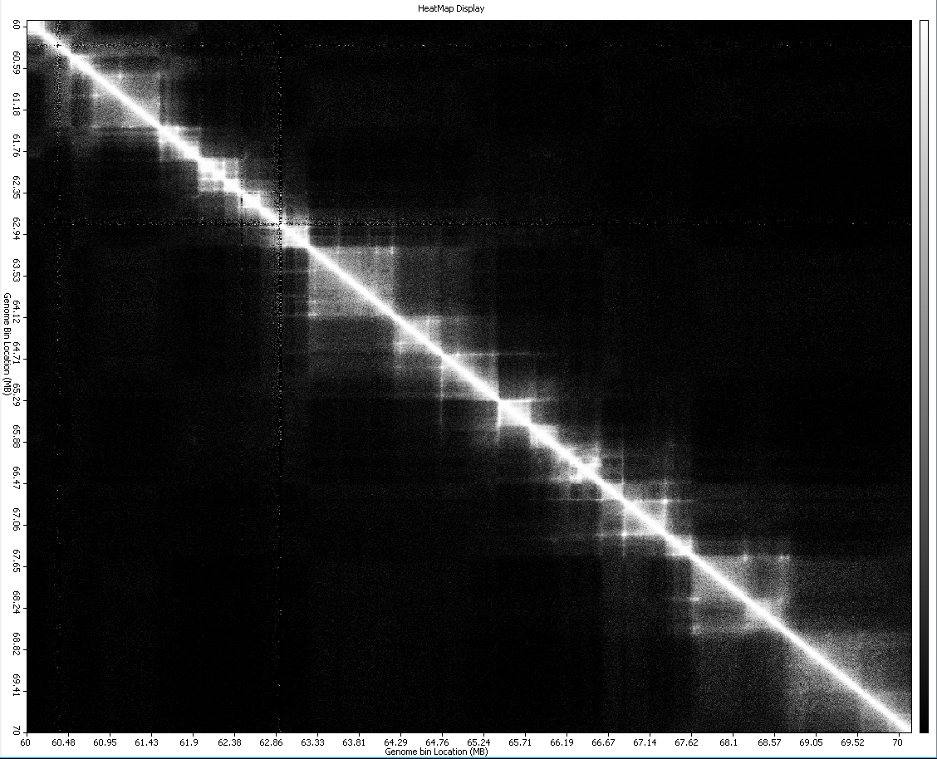

1. Choose the color gradient to represent the input dataset. The Heatmaps below shows the dataset representation for each of the gradient representation when **Tanh dataset** is used.

**BLACK_TO_WHITE GRADIENT**



**BLUE_TO_RED GRADIENT**

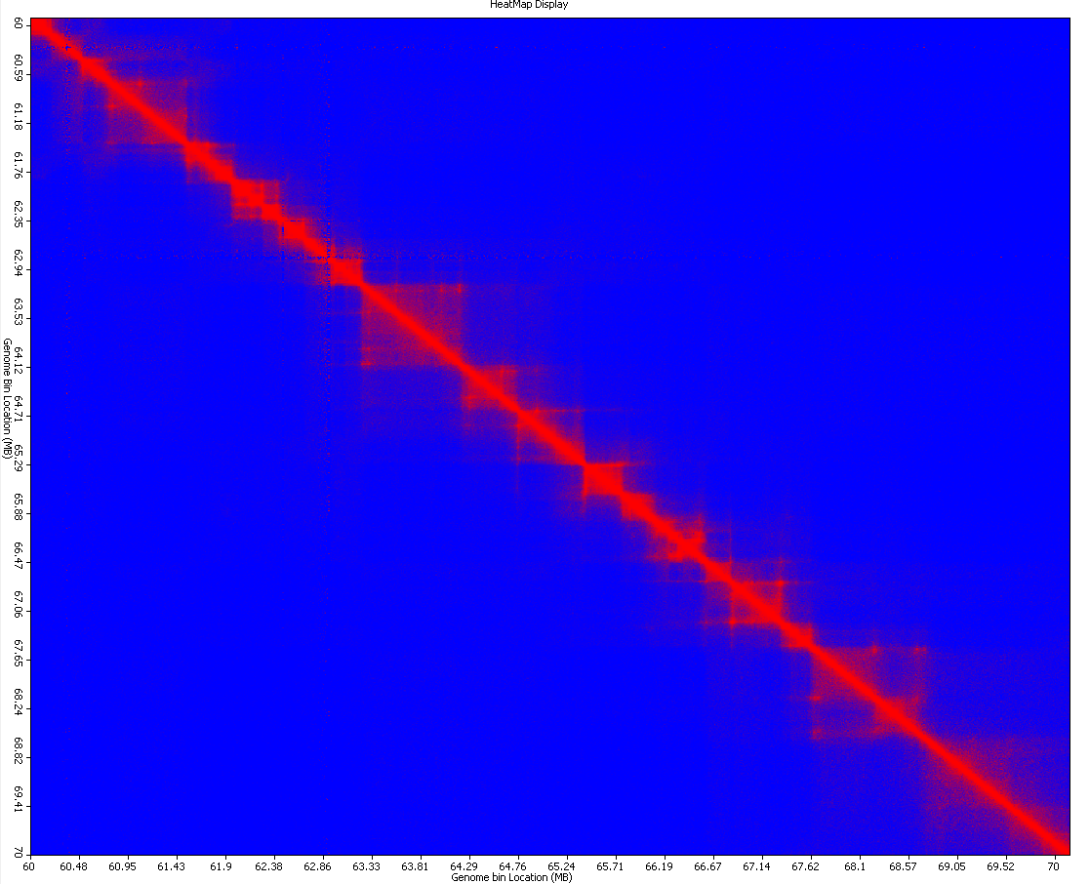

**GREEN_YELLOW_ORANGE_RED**

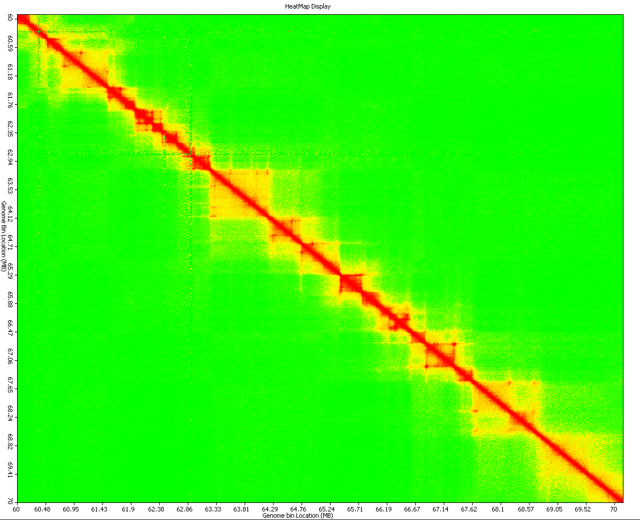

**HEAT**

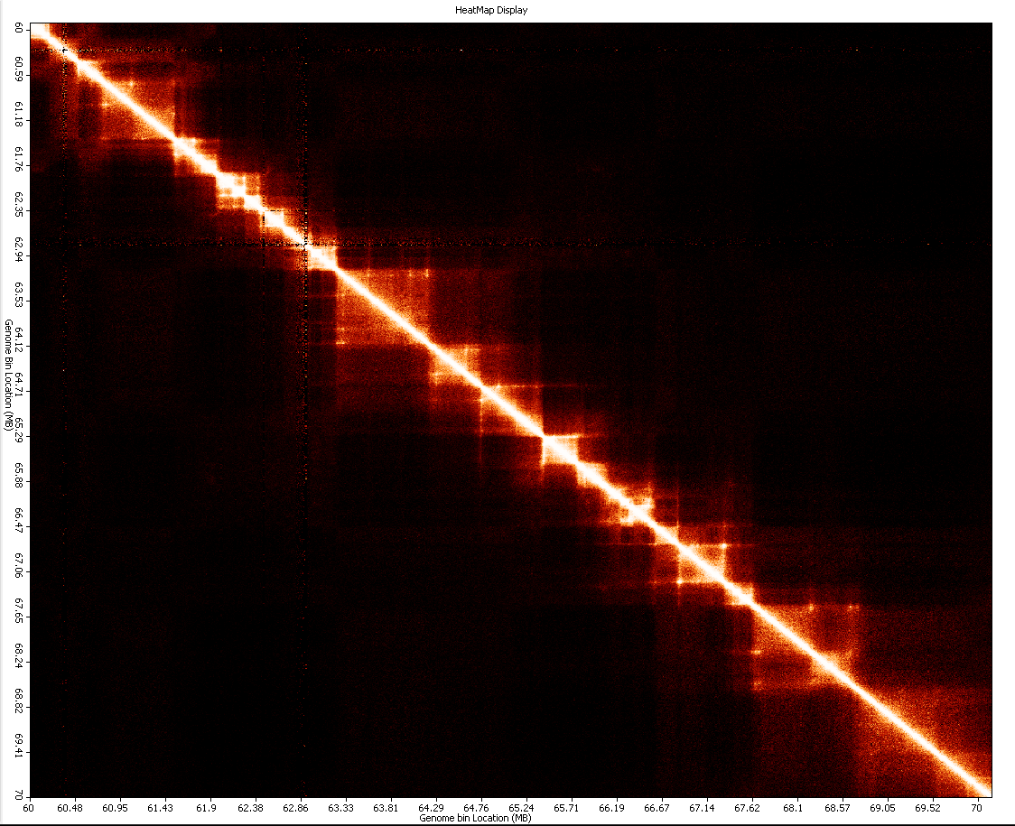

**HOT**

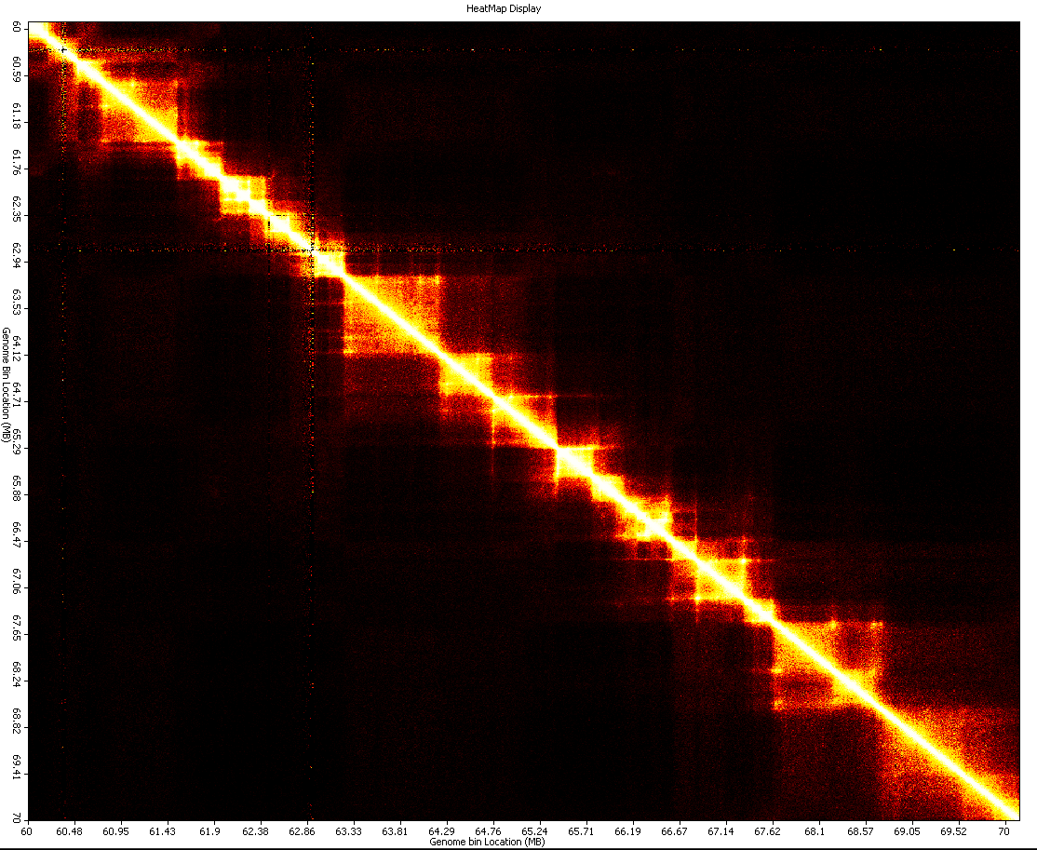

**MAROON_TO_GOLD**

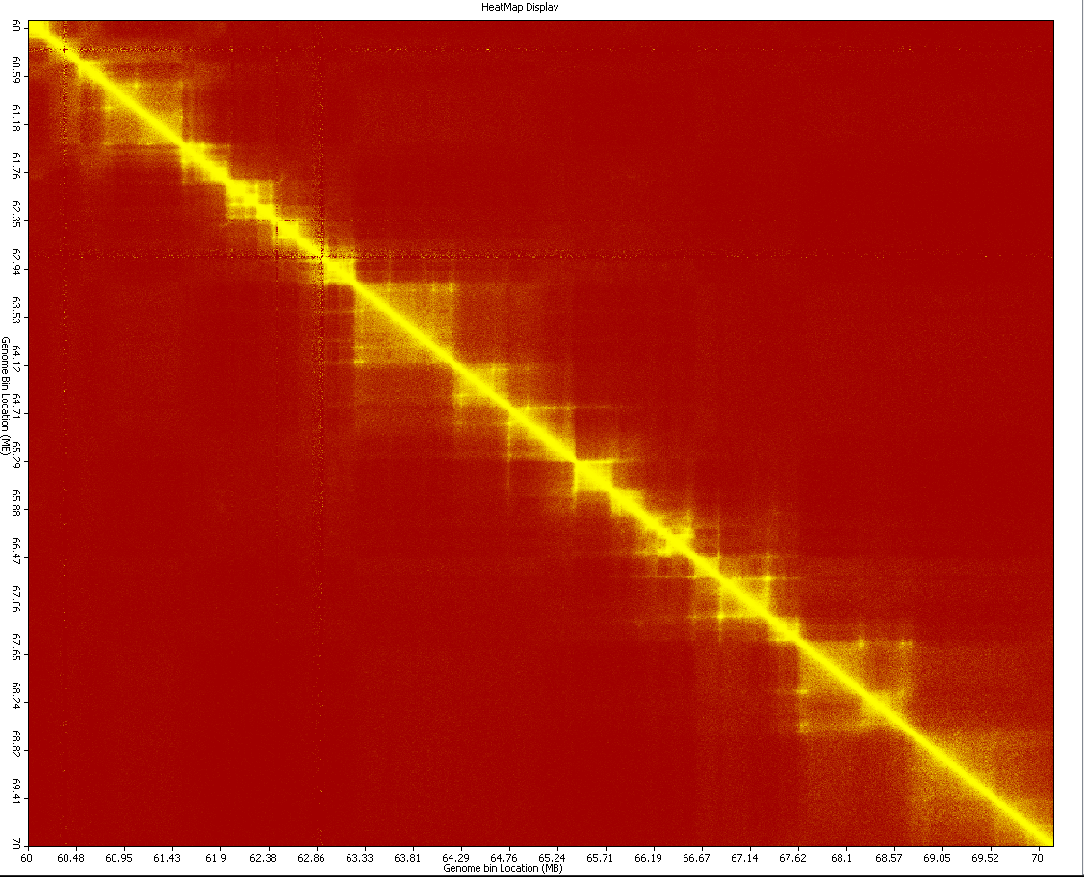

**RAINBOW**

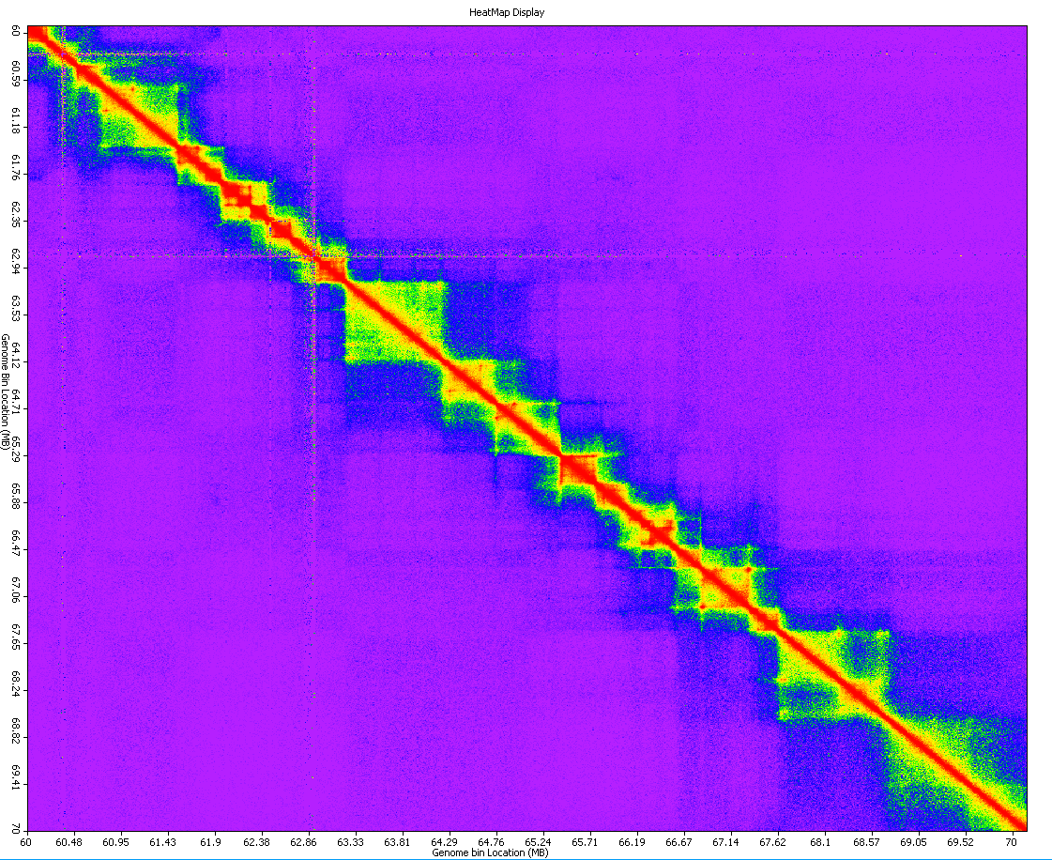

**RED_TO_GREEN**

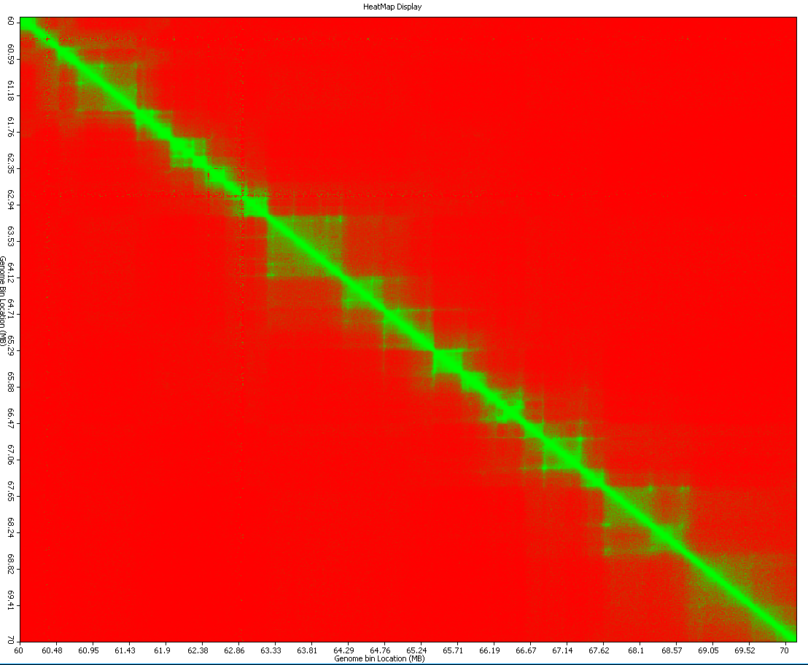

## How to show TAD on the Heatmap?

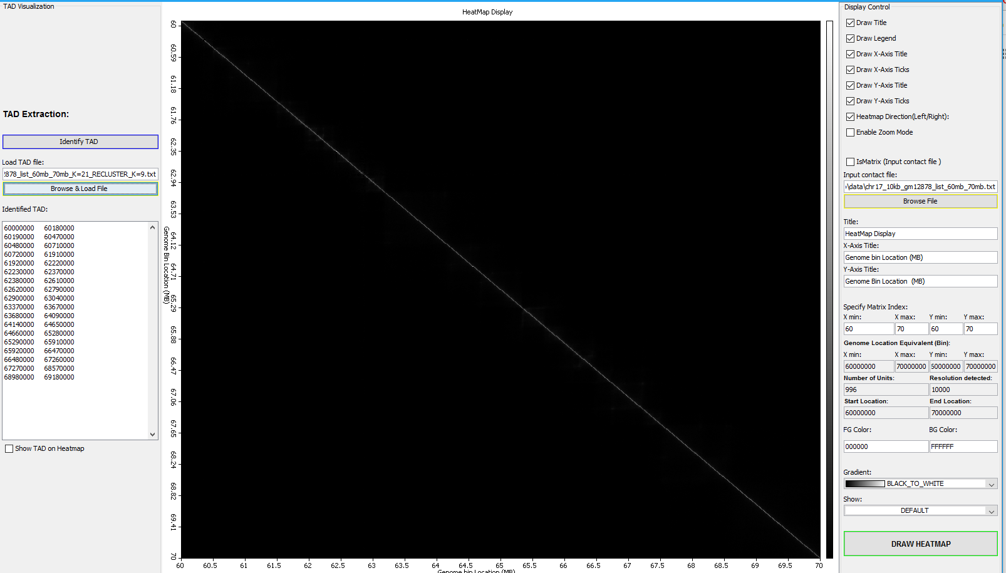

1. Click on the Browse and Load File button to load previously identified TAD
2. Check the Show TAD on Heatmap Check box to visualize the extracted TAD in the display window
3. The heat maps below shows the result obtainable when user clicks the Show TAD on Heatmap button.

|  |  |
| --- | --- |
| **Gradient = RAINBOW** | **Gradient = RAINBOW, Show = Tanh** |
|  |  |

**Gradient = HEAT, Show = Tanh**

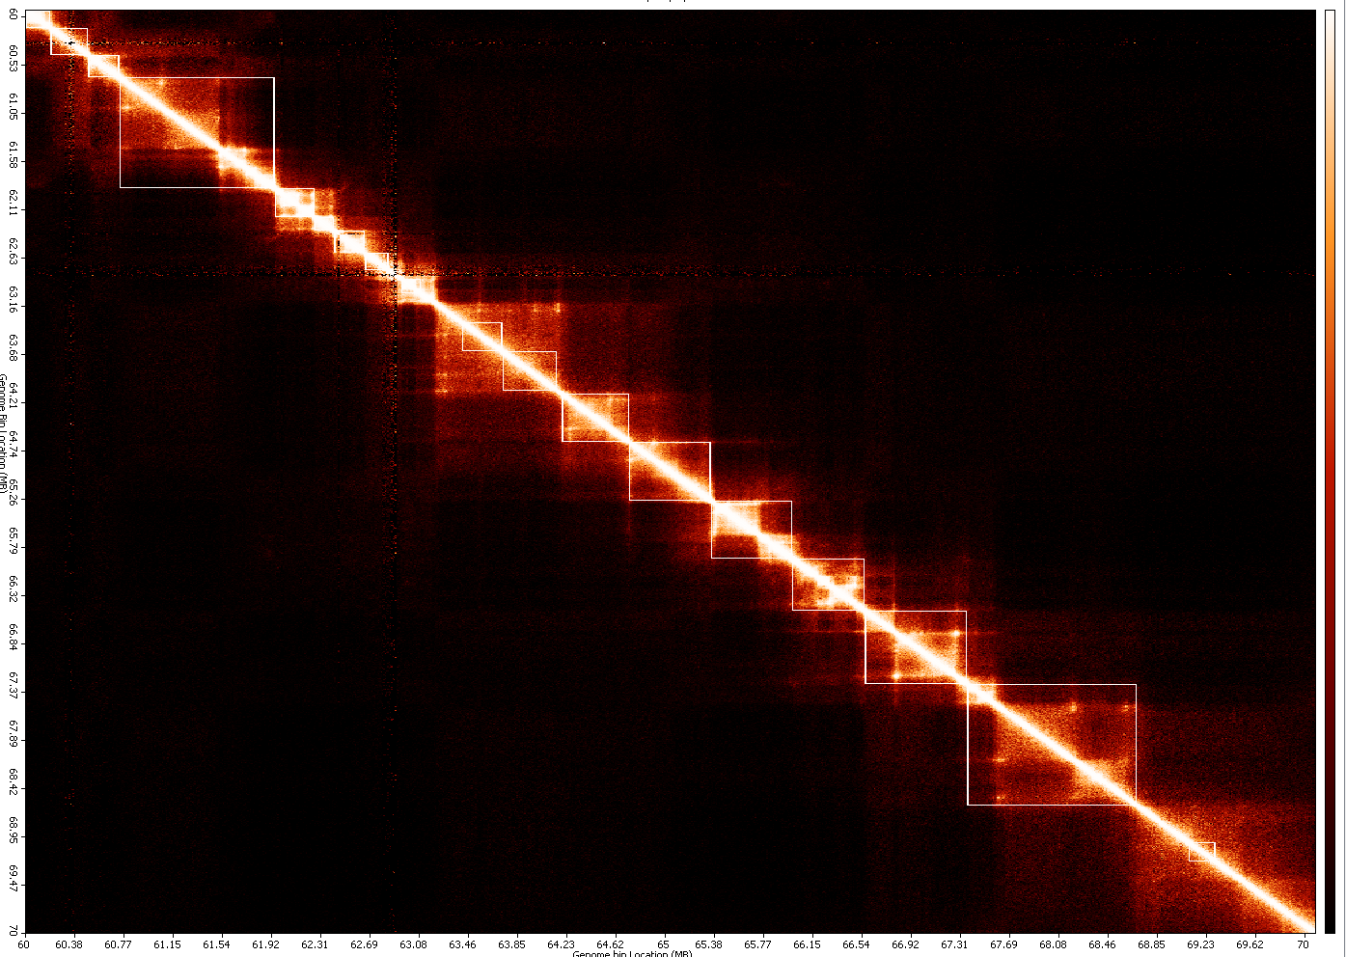

1. The **squares** at the diagonal, are the TAD identified for the dataset.